Name: Jing Cao
Date: 09/02/2019
15.07 Picture Lab Worksheet
Directions: Make note of your responses to the following questions as you work through the activities and exercise in the lesson.
Activity 5 Questions
Question | Yes | No
- Is the method getPixels2D in the Picture.java class? |  | x
- Is the method getPixels2D in the SimplePicture.java class? | x
- Will the following code compile?  DigitalPicture p = new DigitalPicture(); |  | x
- Assuming a no-argument constructor exists for SimplePicture, will the following code compile?  DigitalPicture p = new SimplePicture(); | x
- Assuming a no-argument constructor exists for Picture, will the following code compile?  DigitalPicture p = new Picture(); | x
- Assuming a no-argument constructor exists for Picture, will the following code compile?  SimplePicture p = new Picture(); | x
- Assuming a no-argument constructor exists for SimplePicture, will the following code compile?  Picture p = new SimplePicture(); |  | x

Activity 5 Exercise Results

- Describe your method for keepOnly red, blue, or green.
public void keepOnlyGreen()
{
zeroBlue();
zeroRed();
}

- For the negate method, paste your code related to calculating and setting the values for red, blue, and green.
public void negate() {

Pixel[][] pixels = this.getPixels2D();
for (Pixel[] rowArray : pixels)
{
for (Pixel pixelObj : rowArray)
{
pixelObj.setRed(red - 225);
pixelObj.setBlue(blue - 225);
pixelObj.setGreen(green - 225);
}
}
}
- Paste a copy of the image that is the result of calling the grayscale.
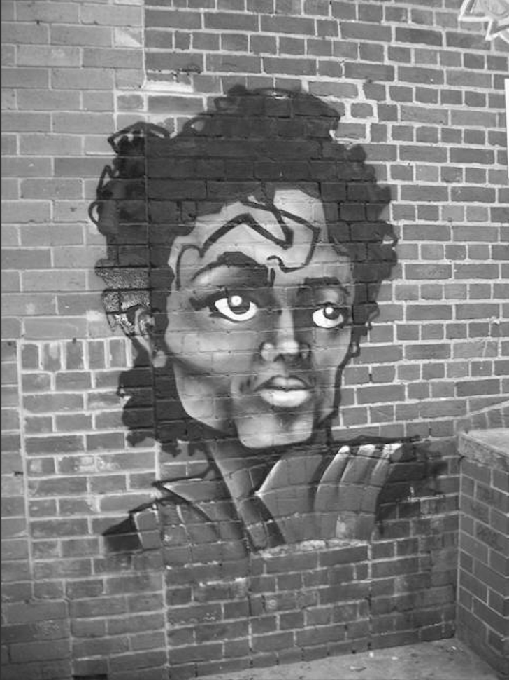
- For the method fixUnderwater, describe the algorithm you'd propose to accomplish the task.
I would make an algorithm to decrease the blue and increase the contrast to make the fish easier to see.
Activity 6 Exercise Results
- Paste the image that is the result of calling the method mirrorVerticalRightToLeft.
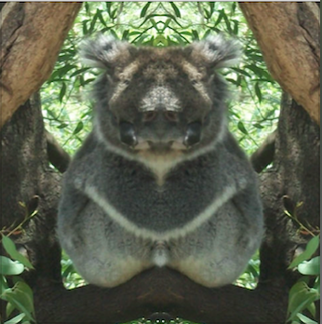
- Describe the algorithm for the method mirrorHorizontal works.
You do the same thing for mirrorVertical except you change it so that pixels[row][width − 1 − col] becomes pixels[height – 1 - row][col];.
- Paste the image that is the result of calling the method mirrorHorizontalBotToTop

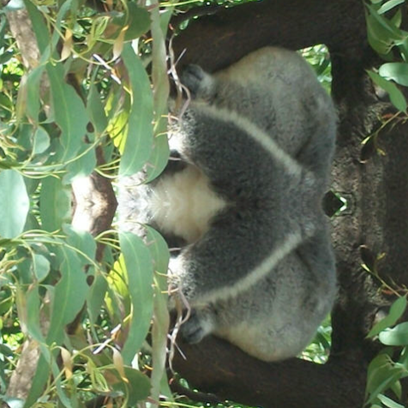

Activity 7 Questions
  - How many times would the body of this nested for loop execute? ___90__
for(int row = 7; row < 17; row++)
for(int col = 6; col < 15; col++)
  - How many times would the body of this nested for loop execute? ___112__
for(int row = 5; row <= 11; row++)
for(int col = 3; col <= 18; col++)

Activity 7 Exercise Results

- What value is displayed for count after the nested loop ends in the mirrorTemple method? __18410__
- Paste the image that is the result of calling the method mirrorArms.
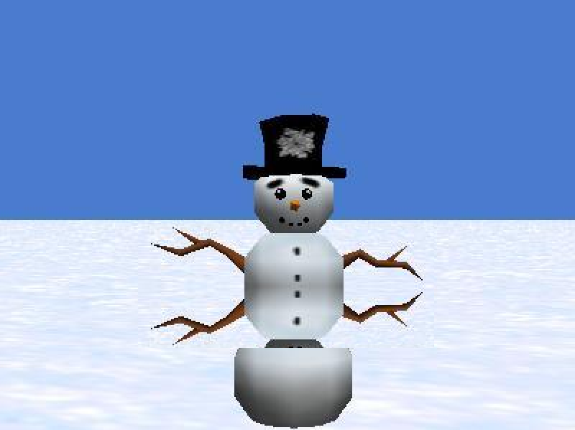
- Paste the image that is the result of calling the method mirrorGull.
